Shipley’s Crossing Homeowners Association, Inc.

ARCHITECTURAL GUIDELINES

FOR

SHIPLEY’S CROSSING COMMUNITY

Overview

The objectives of these design Guidelines are:
- To protect property values and enhance the investment of residences locating in the community by insuring a well-planned and well maintained development.

- To create an attractive and efficient residential environment through sound planning and design standards.

- To insure harmonious relationships among the design elements of the Community, including architecture, signage, landscaping, and fencing.

The Guidelines are intended to acquaint the residents of Shipley’s Crossing North (SCN) and Shipley’s Crossing South (SCS) with the level of quality expected. The Guidelines establish design and implementation standards and serve as a framework for Homeowners when modifying and/or improving their property.
The Architectural Review Committee (ARC) is composed of homeowners from both SCN and SCS, and appointed by the Board of Directors. One board member will serve as the chair of the ARC. The Guidelines may be modified from time to time to reflect governmental requirements or in the ARC’s judgment, the benefits of advanced technology, improved efficiency, or progressive design concepts which enhance the community.

Nothing in these Guidelines shall take precedence over any applicable government agency rules or regulations. However, where the Guidelines are more restrictive, the Guidelines shall prevail.

It is important to understand that the ARC approval is not limited to major alteration such as adding a deck to a house, but includes such items as changes in exterior color and materials, etc. Approval is also required when an existing item is removed.

Each application is reviewed on an individual basis. There are no "automatic" approvals, unless provided for specifically in these design standards. For example, a homeowner who wished to construct a deck identical to one already approved by the ARC is still required to submit an application, and be pre-approved prior to the start of construction.

Architectural Review
Except as otherwise provided in this Declaration or in any rules or regulations adopted by the Board of Directors of the Association, no Structure shall be placed or constructed· on any Lot, nor shall any addition (including awnings, screen doors and screens), change or alteration (including any change in exterior paint color or materials or other exterior appearance thereof, but excluding repainting or retreating with the same color or materials and seasonal decorations) (collectively, "Alterations"), be made to the exterior of any Structure or the contour of any Lot until plans and specifications, showing the nature, dimensions (including elevations and roof pitch or change in the grade of the Lot), material, color and location (including proposed front, rear and side setbacks) of the proposed Structure or Alterations, together with the proposed construction schedule, a designation of the party or parties to perform the work, photographs of the existing improvements or area to be improved, and other information requested by the ARC, have been submitted to and preliminarily approved in writing by the Architectural Review Committee, and until all necessary permits and other governmental or quasi-governmental approvals shall have been obtained. The pre-approval of the Architectural Review Committee of any Structure or Alterations shall in no way be deemed to relieve the Owner of any Lot from its obligation to obtain any and all governmental permits and approvals necessary for such Structure or Alterations, including but not limited to grading, building and occupancy permits.

All questions before the Architectural Review Committee shall be decided by a majority of the ARC members. Any member who is aggrieved by any action or forbearance from action by the Architectural Review Committee may appeal the decision to the Board of Directors and, upon the request of such member, shall be entitled to a hearing before the Board of Directors of the Association. Such appeal shall be made by the member in writing to the Board of Directors within fifteen (15) days after the date of the notice that such plans and specifications have been rejected by the Architectural Review Committee. The appeal hearing shall be held at the next regularly scheduled board meeting, but in any event not less than thirty (30), but not more than sixty (60) days after the date the notice of the appeal is received in writing by the Board of Directors. The decision of the Board of Directors shall be final and unappealable.

The Architectural Review Committee shall have the right to disapprove any plans and specifications submitted for its review because of any of the following:

- Failure of the plans or specifications to comply with any provision of this Declaration, applicable law, or other Guidelines adopted by the Architectural Review Committee;
- Failure to include information in the plans and specifications required by this Declaration, or as may have been reasonably requested by the Architectural Review Committee;
- Objections to the exterior design, appearance or materials of any proposed Structure or Alterations;
- Incompatibility of any proposed Structure or Alterations with the existing Structures on the Lot or other Lots or with the general plan of improvement of the Property

General Guidelines applicable to both the North and South Sides

- Driveways and Garages: Driveways shall be maintained in good condition and in accordance with all applicable laws. Gravel surfaces are prohibited. Garages may not be converted to additional living space
- Temporary Structures - No temporary structure, including but not limited to a trailer, shack or outbuilding shall be permitted to be stored or erected on any site. The foregoing shall not be deemed to prohibit reasonably sized garden sheds or similar accessory structures approved in advance by the Architectural Review Committee.
- Outside Stair Railings- The ARC recognizes that certain homes might like to install hand railings on the entrance steps to their home. Entrance step railings must be either wrought iron or aluminum. The specific design of the railing must be approved by the ARC. Railing color is limited to black only.
- Clotheslines - Maryland legislation passed in 2010 permits homeowners’ associations to enforce reasonable restrictions on the usage of clotheslines in order to preserve the aesthetics of a community. The legislation is commonly referred to as the “right-to-dry” law. SCHOA modified former guidelines to now permit clotheslines to be set up for a period of not more than 8 hours per day, and must be taken down not later than 5:00 p.m. daily. The clothesline must be set up no higher than 6 feet from the ground level at the rear of the lot on the ground level, and the clotheslines system cannot be a permanent fixture or structure. Clotheslines are not permitted to be installed or used at the deck level of a lot. No clothing, bedding, sheets, towels, or other personal clothing items or property shall be hung from any window, deck, balcony, or patio of any dwelling situated on any lot or any common area. Violation of these rules shall be a fine of $40.00 per day per incident to a maximum of $1,200.00 in 30 days.
- Flagpoles - Freestanding flagpoles are prohibited. One (1) appropriately sized flagpole may be mounted on the front of a dwelling.
- Bird houses/bird feeders - No more than two bird houses\bird feeders or a combination of the two may be set in the back yard on a lot. A bird feeder may hang from a Shepherd’s hook or a 4’x4’ post consistent with existing deck rail, or pressure treated natural wood, not exceeding six feet (6’). Any exception to this guideline would be on a case-by-case basis and must be pre-approved by the ARC.
- Landscaping-Exterior landscaping shall be reviewed on a case by case basis to assure they conform with the existing aesthetics of the neighborhood. The front and side yards of each Lot shall be kept only as a lawn for ornamental or decorative planting of grass, trees, shrubbery and flowers. Except for seasonal decorations, lawn statues and similar ornaments are expressly prohibited in front and side yards and they should not exceed three feet (3’). No equipment or machinery for use in connection with the maintenance of a dwelling, such as lawnmowers, wheelbarrows and similar devices shall be stored in the front or side yard of any lot. Owners shall maintain their respective Lot and exterior of their dwelling in good order and repair. Any plant material must be on the approved list for Anne Arundel County (see approved list on community website).
- No obnoxious or offensive activity shall be carried on or upon any Lot.
- No animals of any kind including pigeons or other non-domestic or exotic animals, shall be raised, bred, or kept on any Lot, except for dogs, cats or any household pets, not to exceed a total of four (4). Animals must be restrained with a leash at all times and cannot be chained or left to roam unattended on the property. Puppies and kittens in excess of the numbers set forth above may be kept until they reach the age of 12 weeks.
- Vehicles - No commercial vehicles with a rated cargo capacity exceeding 3/4 ton, trailers, boats, buses, campers, recreational vehicles, limousines, hearses, ambulances, multi-purpose passenger vehicles designed to carry ten (10) or more persons, tractors, junked, unlicensed or inoperable passenger vehicles or any other vehicle, other than licensed private passenger vehicles in regular operation, shall be parked regularly on any roads or parking areas within the Property or on any Lot unless garaged. Carports shall not be permitted on any Lot. The foregoing restriction shall not prohibit temporary parking for washing and polishing of vehicles or for a visiting motor home or house trailer, which shall be permitted to remain for no more than two (2) consecutive weeks in any six-month period.
- Lighting/Wiring & Antenna - All exterior lightning shall be directed downward and shielded to minimize the casting of light onto neighboring Lots. Lot lighting shall require ARC approval. All wiring shall be underground. No exterior antennas of any type, including, but not limited to satellite dishes for reception or transmission are allowed. However, satellite dishes not in excess of one (1) meter in diameter are permitted subject to approval as to location and appearance.
- Trash and Other Materials - No lumber, metals, bulk materials, refuse or trash shall be kept, stored or allowed to accumulate on any Lot, except building materials during the course of construction of any approved structure. No burning of trash shall be permitted on any Lot. Other than for normally scheduled pick up days all trash and recycling containers shall be stored so as not to be visible from the roadway, other Lots or Common Area.
- Non-interference with Utilities - No Structure, fence, planting or other improvement shall be placed or permitted to remain upon any Lot, which may damage or interfere with any easement for the installation or maintenance of utilities.
- Patios - Patios shall be constructed of slate, stone, concrete, or such materials as may be specified or approved by the Architectural Review Committee.
- Awnings -Awnings (other than as part of an approved screened or enclosed porch) are discouraged and must be approved in advance by the Architectural Review Committee on a case-by-case basis. Retractable awnings, approved in advance, may be installed over decks and patios in rear yards.
- Window Treatments - Bed sheets, plastic sheets, newspapers, or other similar window coverings shall not be hung or placed in or on any window or any dwelling located on any Lot either permanently or temporarily.
- Storm doors - Storm doors (or screened doors) shall be full view and anodized aluminum and shall be painted the same color as either the door or the trim of the house, or of such material and color as specified by the Architectural Review Committee.

ARC Guidelines specific to SCS

1. All Lots shall be used for private, single family residential purposes only and no dwelling of any kind whatsoever shall be erected, altered or maintained hereon except one private dwelling house for the sole purpose and exclusive use of the owner or occupant of the Lot. No industry, business, trade or shops of any kind, whether or not for profit, professional or otherwise shall be maintained or permitted on any part of the Property without the prior written consent of the Board of Directors.
2. Swimming Pools/Hot Tubs - No pools are permissible on any Lot. Hot tubs shall be permitted if approved in advance by the Architectural Review Committee in its sole and absolute discretion. Notwithstanding the foregoing, portable children's pools constructed of plastic material may be maintained on the rear yard of any Lot during the months of May through September of each year.
3. Fences and Walls - Fences and walls or other similar enclosures may be built on any Lot in the rear and side yards only, and only with the prior written approval of the Architectural Review Committee. Please note the requirements on the attached Standard Fence Detail (see Fence Detail on community website).
4. Decks and Porches - Decks, patios, screened and enclosed porches may be built on any Lot only with the approval of the Architectural Review Committee and upon obtaining a valid building permit. Decks and porches shall not extend forward of the rear foundation wall into any front or side yard. Decks and porches shall be constructed of pressure treated lumber or long-life cedar, redwood, trex or other similar material. Color shall conform to the color scheme of the dwelling.
5. Exterior House Colors - Any changes from the original colors must be approved by the Architectural Review Committee and be compatible with the colors existing in the community. Color samples must be submitted for approval.
6. Play Equipment - Play equipment shall consist of pressure treated wood, cedar, redwood or high-grade plastic materials. It shall be placed in the rear yard and in an area to minimize views of it from neighboring properties. No play equipment may be attached to existing homes. No play equipment, portable or otherwise will be permitted in front or side yards.
7. Sheds/Accessory Structures- Sheds or other similar accessory structures such as greenhouses shall be permitted in the rear yard only provided that such structures shall not exceed one (1) story in height (maximum wall height shall not exceed 6'-6" ). Sheds shall be the same color and material as the exterior of the dwelling and shall be sized appropriately with the space available in the rear yard. Accessory Structures. The shed size related to the total lot area has been eliminated in favor of a system that will evaluate the available area in the rear yard for a shed to be placed. Essentially each request will be considered on a case-by-case basis.

ARC Guidelines specific to SCN

- Fences and Walls.
Important Subject: Egress Window Grating

No fencing, wall, plants, or any other encumbrances shall be placed in front of the egress window grate for a depth of 42” inches from the outer edge of the window well. The window grate is about 3 ½ feet at its deepest point and should be allowed to slide off, rather than having to be lifted. This is recommended by the Anne Arundel Fire Department

Fences and walls or other similar enclosures may be built on any Lot in rear or side yards only, and only with the prior written approval of the Architectural Review Committee; provided, however, that such fences and walls as may be installed or constructed by the Declarant or any Builder simultaneously with the initial construction of a dwelling on a Lot shall not require Architectural Review Committee approval. Homeowners must follow the guidelines described and as shown below. All fencing shall comply with the height, setback and other requirements of applicable law. Chain link and chicken wire fencing is expressly prohibited. All gates must open inward onto a Lot and shall not open onto another Lot or the Common Area. An ornamental hedge fence shall be kept neatly trimmed, and shall not exceed three (3) feet in height in front yards, or side yards of corner lots.

Fence Guidelines

- Fence height. 48” only with at least a 2” clearance at the bottom for ease of landscaping maintenance
- Fences must be installed on the property line. (Multiple fences on the same property line will not be allowed)
- Fence pickets, posts, railings, pergolas and arbors, must be white vinyl PVC only
- No privacy fences
- Spacing of pickets must conform to local building codes
- Solid sections are not allowed
- The image below specifies the form and picket type to be used on all fences
- Caps on posts are “Traditional New England”
- Fence picket tops should be “Sharp Picket” or “Dog Ear”

White PVC Picket Fence with “Dog Ear” picket tops
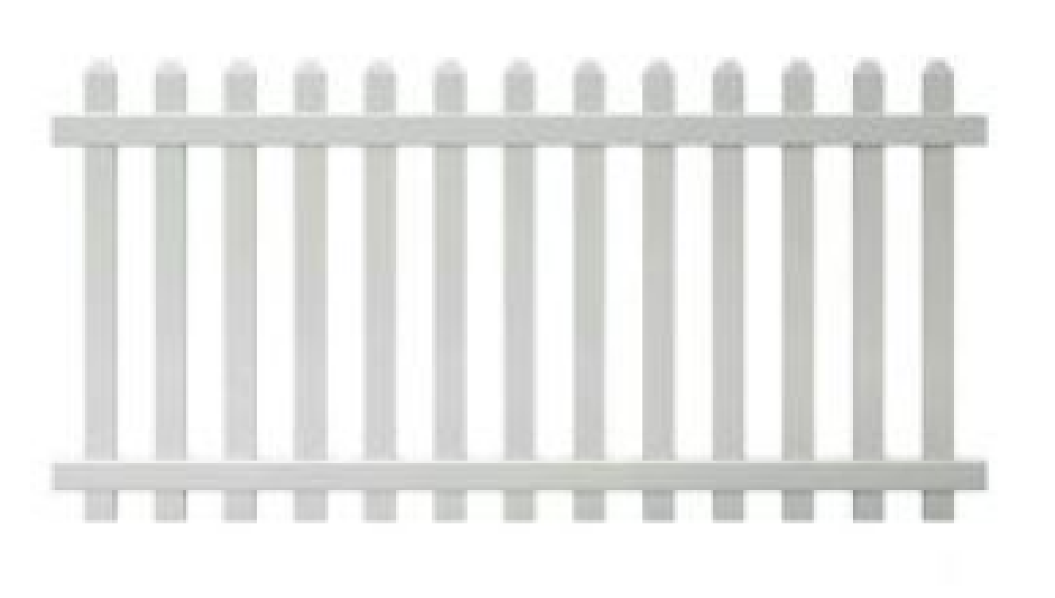

2. Patios, decks, and porches must be compatible in material, scale, and the design intent of the architectural style of SCN. No deck or porch shall extend forward of the rear foundation wall. Design consideration include the following;
- Patio materials shall be slate, stone, brick, or concrete or the same material as the deck
- Support sections of decks shall be constructed of a pressure treated lumber
- Deck surface will be either Trex or similar manufactured composite decking material, with a white vinyl PVC rail system
- Decks must have at least a 1-foot setback from property line
- Two privacy screens, not to exceed six feet in height or width is allowed as part of the deck railing system

